comments are just to allow you to place text on the screen without placing a field.

it's just standard text. So, to place comments on the selection screen, we would use the following syntax.



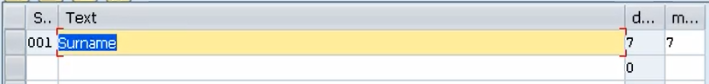



You can either use a text symbol or a field name. But your field name must be a maximum length of eight characters. And this character field must not be declared with the data statement.

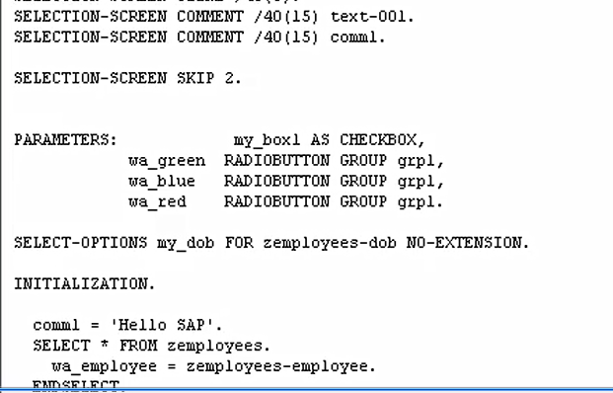But it is generated automatically when we declare the length of our comment.

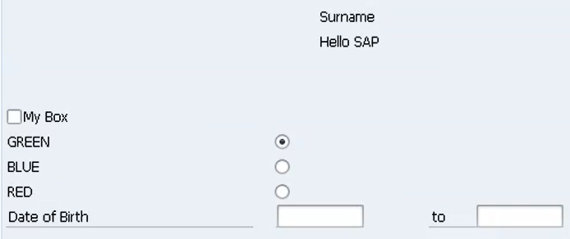

Don't forget, I've said we don't declare this variable ourselves with the data statement. Just by us using this statement with a specific length, the system created it for us. So here, let's specify comments 1.

Just comm1. So now you'll probably think, well, what does it contain? Well now it contains absolutely nothing. So, what we must do is, when our program has first started, we must fill comm1 with some data. And if we go down and have a look at the initialization section, that's where we can put this code.